Computer Games Programming

CUP574

AE1 Project Report

Nathan Jowett

Q162788488

Contents

Introduction 2

Technical Design 3

Testing 6

Reflection 9

# Introduction

We have been tasked with making a 2D game using SDL. This is my first-time using SDL so there has been a big learning curve throughout the project. My game has taken inspiration from games such as Space Invaders or one of my favorites as a kid… Chicken Invaders. The game started as an endless runner with the idea of dodging ships and meteors, this has then since changed into more of the style of the games previously mentioned. The main aim of this game is to firstly survive and avoid oncoming traffic alongside using your ships laser to destroy said objects until none remain.

In this report I will include technical design documents, my project testing table with outcomes and evidence as well as a reflection of the project.

# Technical Design

UML Class Diagram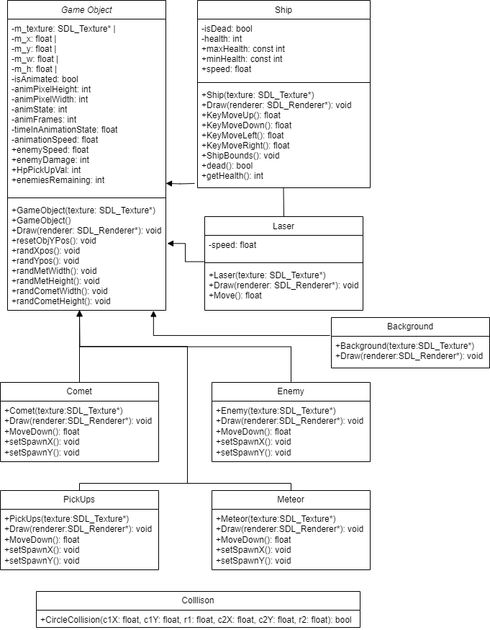

Pseudocode

This pseudocode will briefly describe how the collision works in this game.

Circle Collision (c1X, c1Y, r1, c2X, c2Y, r2)

Calculate the distance between the centers of two circles,

distance = sqrt ((c2X - c1X) ^2 + (c2Y - c1Y) ^2)

Check if the distance is less than the sum of the radius.

if distance < r1 + r2

return true = circles are colliding

else

return false = circles are not colliding

end collision check.

Flow Charts

Main Loop

Enemy Loop

This process is the same for both Comet and Meteor. Pickups class follows the same flow however the only alteration with this class that rather than damage the player it will heal instead.

# Testing

|  |  |  |  |  |
| --- | --- | --- | --- | --- |
| ID | Test | Expected Outcome | Actual Outcome | Pass/Fail |
| 1 | SDL Init | SDL Initializes | SDL Initializes | Pass |
| 2 | Load correct assets (Img, Music, txt) | Loads correct assets | Loads correct assets | Pass |
| 3 | Player Move (Mouse) | Player follows mouse pos | Player follows mouse pos | Pass |
| 4 | Player Move (Keys) | Player movement binds to correct key actions | Player movement binds to correct key actions | Pass |
| 5 | Music looping | Game music loops indefinitely | Game music loops indefinitely | Pass |
| 6 | Player shoot SFX | SFX plays on mouse 1 press | SFX plays on mouse 1 press | Pass |
| 7 | Player boundaries | Player bounds set to window size | Player bounds set to window size | Pass |
| 8 | Player health max value | Player health caps at max value | Player health caps at max value | Pass |
| 9 | Player Death | Player death when health = 0 | Player death when health = 0 | Pass |
| 10 | Game Over Message  (UI) | Game Over drawn when player = dead | Game Over drawn when player = dead | Pass |
| 11 | Player takes damage | Player takes damage as long as they are colliding with enemy | Player takes damage as long as they are colliding with enemy | Pass |
| 12 | Player health updates accordingly | Appropriate damage or health gain depending on collision object | Appropriate damage or health gain depending on collision object | Pass |
| 13 | Player health updates accordingly  (UI) | Health updates on screen when taking damage/healing | Health updates on screen when taking damage/healing | Pass |
| 14 | Player Shoots | Laser spawns at pos of mouse click | Laser spawns at pos of mouse click | pass |
| 15 | Kill enemies | Enemies destroyed when colliding with laser | Score updates but enemies not destroyed | Fail |
| 16 | Enemies remaining  (UI) | Value updates when enemy has been killed | Value updates | Pass |
| 17 | Random spawn pos  (Enemies and Pickups) | On game start, all objects have a random spawn range | On game start, all objects have a random spawn range | Pass |
| 18 | Enemies and pick up movement | Objects move down screen | Objects move down screen | Pass |
| 19 | Appropriate speeds  (enemies and pickups) | Objects should have preset speeds that they maintain throughout | Objects should have preset speeds that they maintain throughout | Pass |
| 20 | Enemies and pickups reset pos | If y >= 950, re set spawn pos within random range | If y >= 950, re set spawn pos within random range | Pass |
| 21 | Random sizes for enemies | Meteors and comets set at random sizes within a range | Meteors and comets set at random sizes within a range | Pass |
| 22 | Destroy laser on contact | If laser collides with ship, laser is destroyed | Laser not destroyed | Fail |
| 23 | Laser bounds | Laser is destroyed if not on screen | Laser continues, causing false scores | Fail |
| 24 | Winner Message | Show player win when enemies remain = 0 | Message is shown | Pass |

|  |  |
| --- | --- |
| ID | Evidence |
| 1 |  |
| 2 | A screenshot of a computer  Description automatically generatedExample of error checking for music, similar checks for img and txt. |
| 3 |  |
| 4 |  |
| 5 |  |
| 7 |  |
| 8 |  |
| 10 |  |
| 13 |  |
| 16 |  |
| 17/18 | A screenshot of a computer  Description automatically generatedEnemies are at a random x pos within a given range  And are at different Y pos to show movement and that rand Y works too. |
| 20 |  |
| 21 |  |
| 24 |  |

# Reflection

I have enjoyed making this project as a whole and this has been a very useful skill to learn and will be something that I’d like to use again whether it be for personal projects or for assignments., I am pleased with the feel of the game and the main core. However, that’s not to say that I did not have my issues along the way and this project is by no means complete either. Currently the shooting and destruction of enemies is broken and not flushed out, which is obviously a major issue, this is mainly down to the fact that I had originally developed this to be an endless runner but then had to change the idea of the game very late into production to accommodate the criteria, which is clearly my fault and an issue I should have spotted early on.

I feel I have improved my coding skills and have learnt many new ways to complete actions such as generating random numbers with the random device. SDL is also a great tool that has made this an enjoyable project due to its capabilities.

If I was to start over, I would focus on a major restructuring and look to use better practice of OOP as this is something I feel this project also lacks. Overall, I am happy with my outcome but understand that there is much improvement needed.